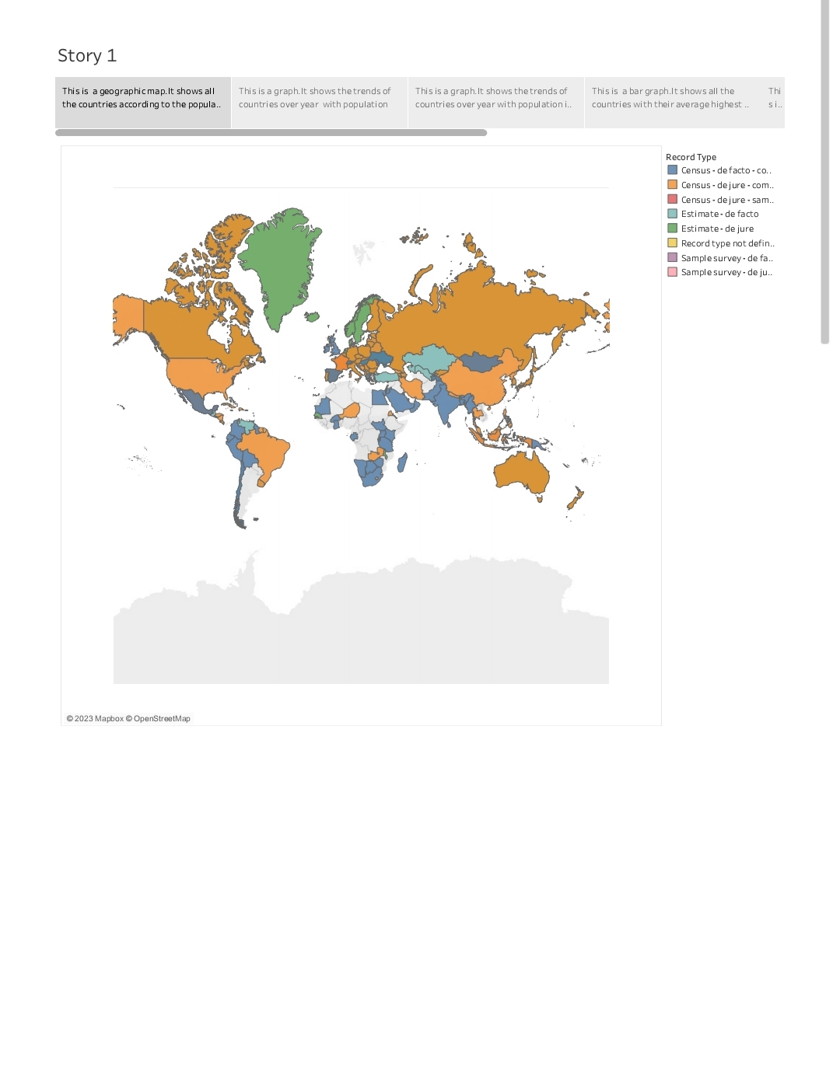

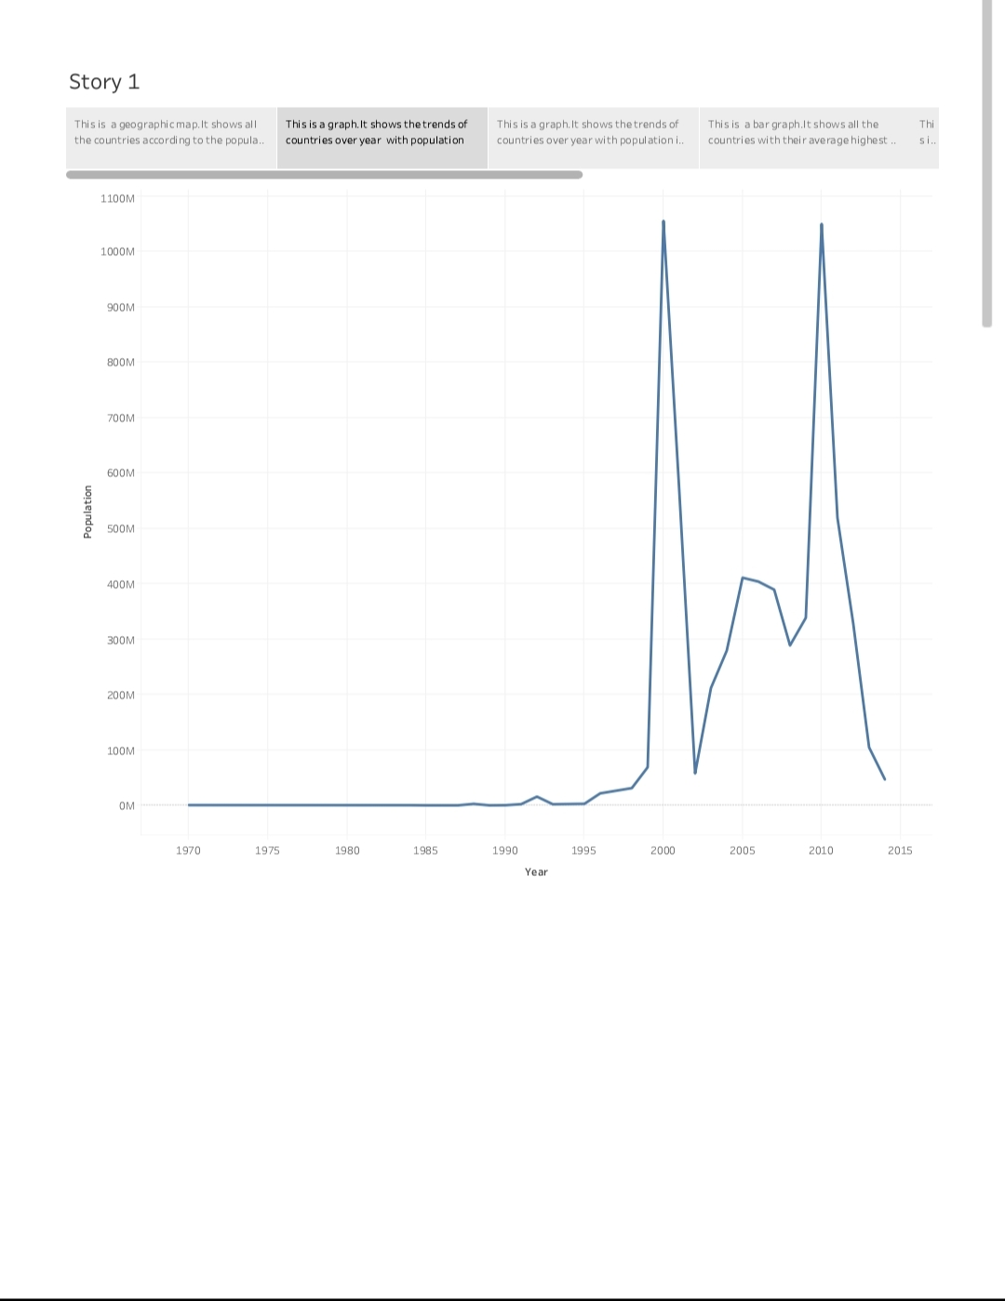

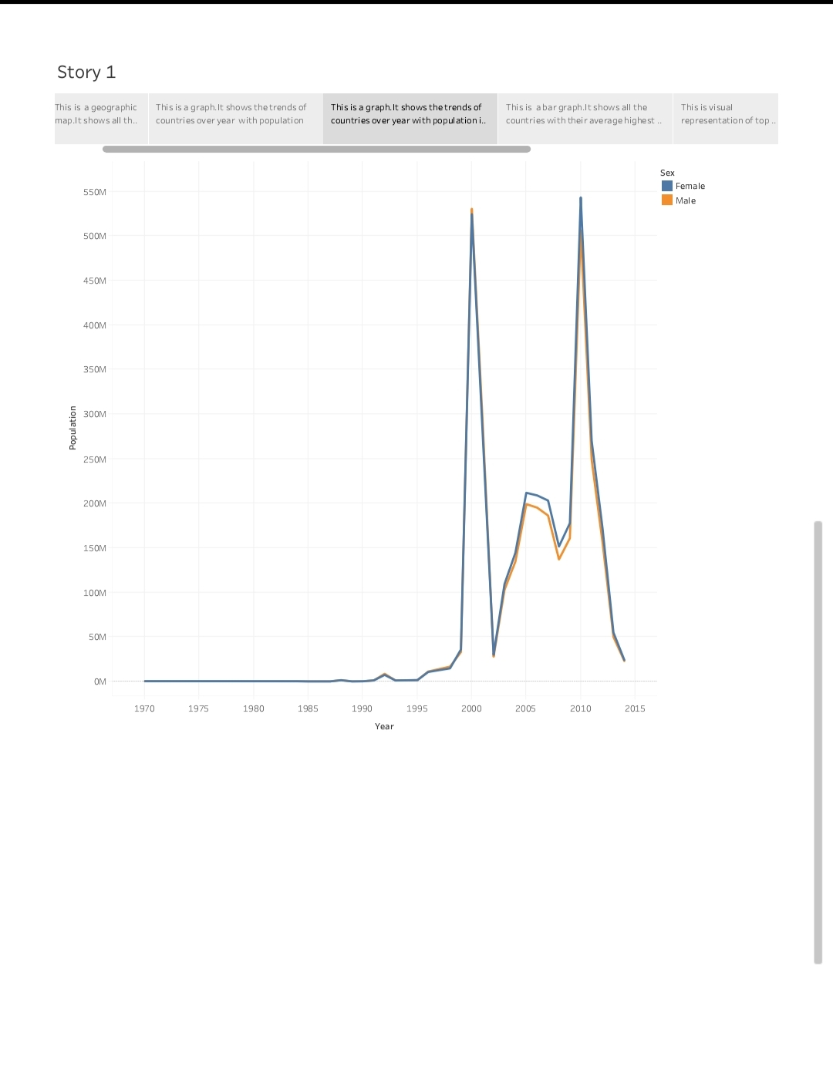

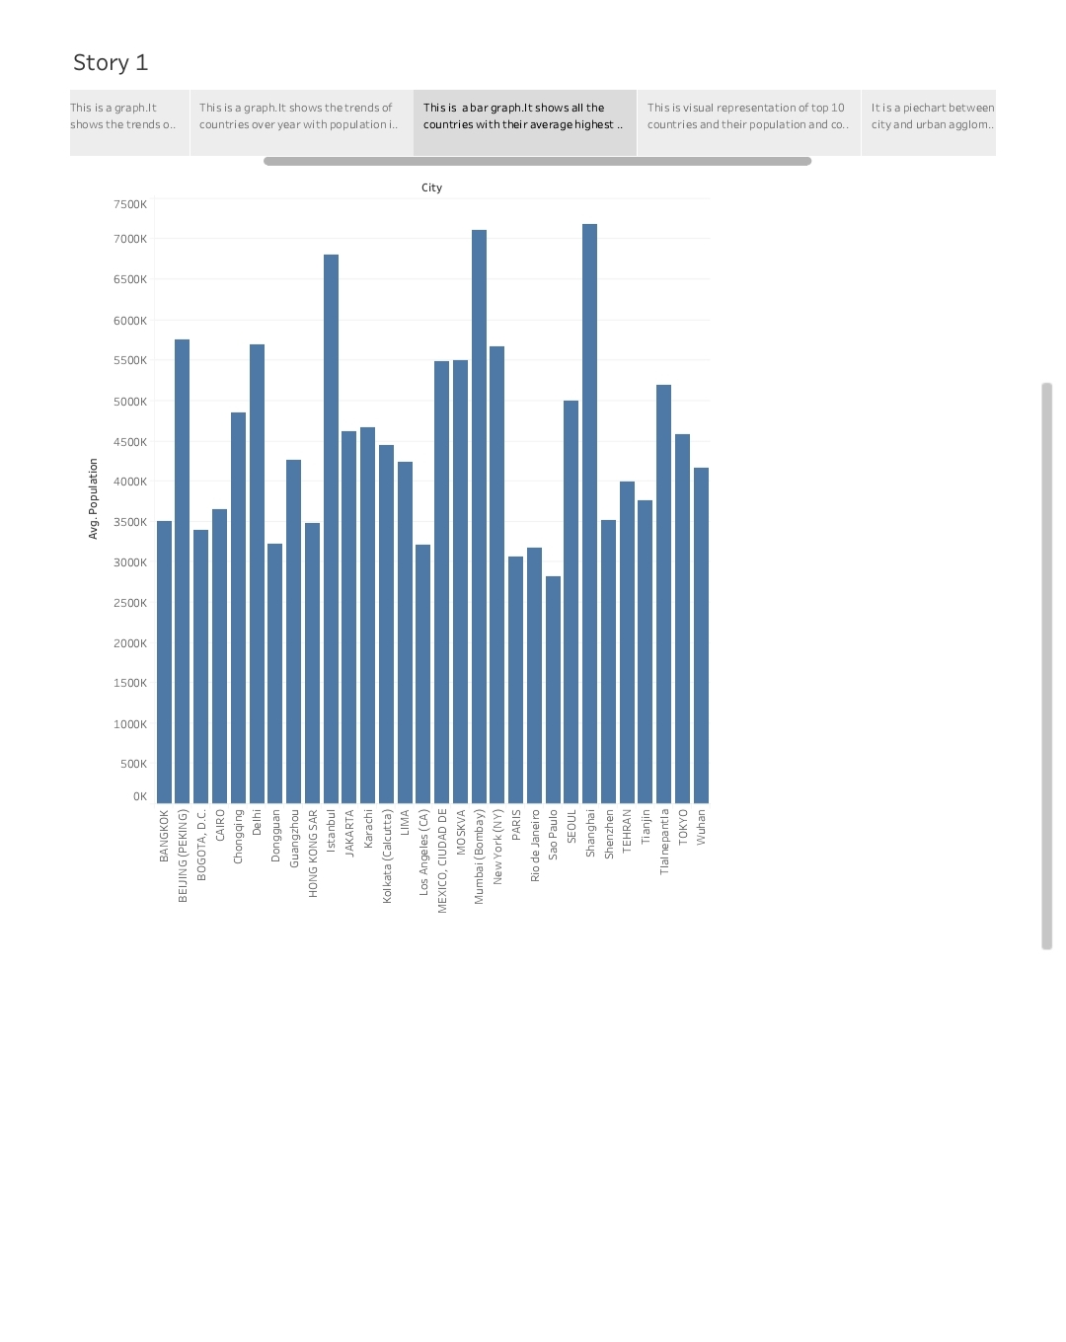

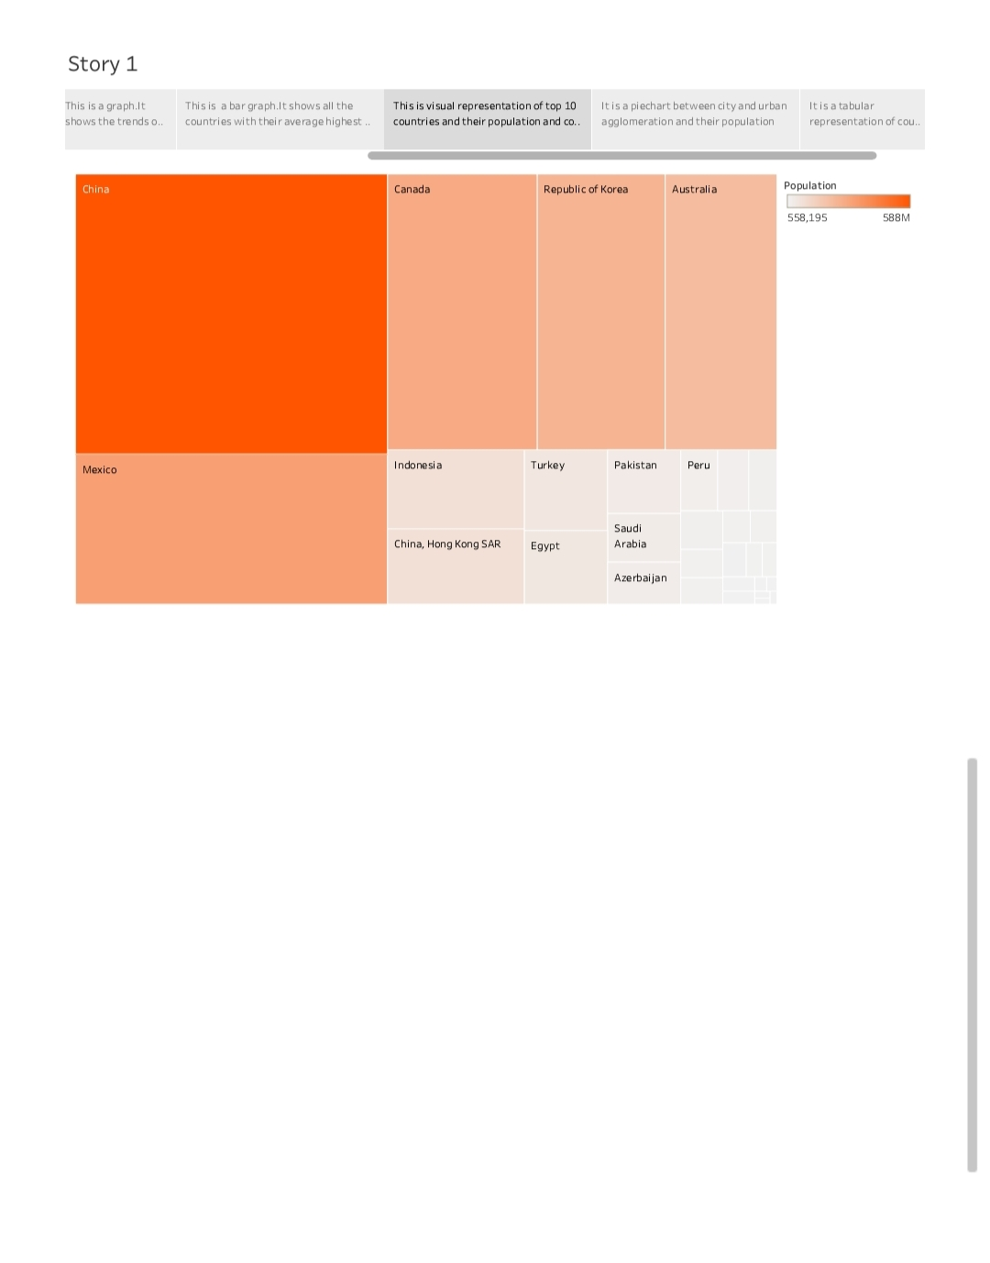

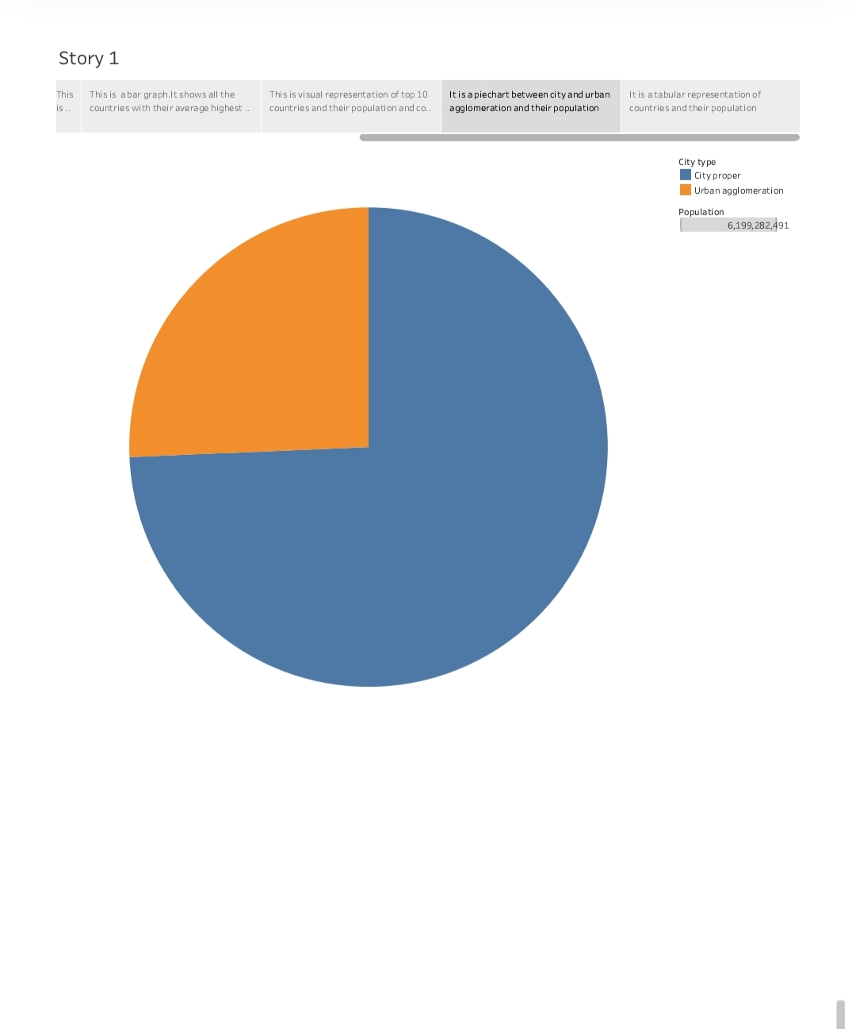

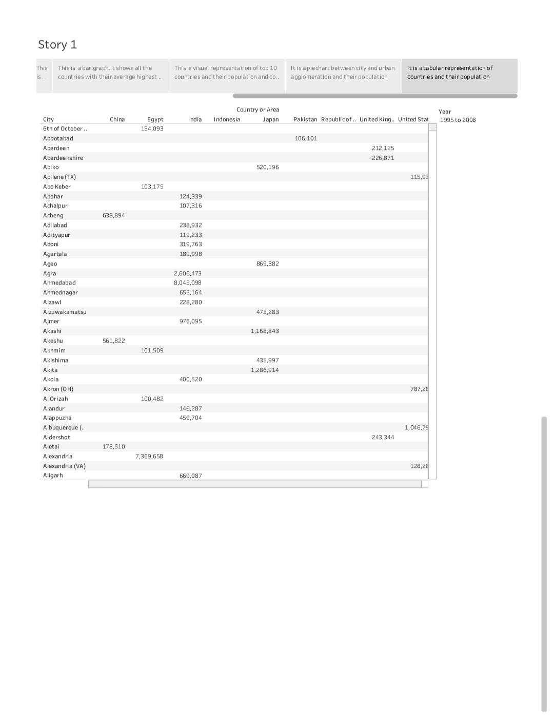

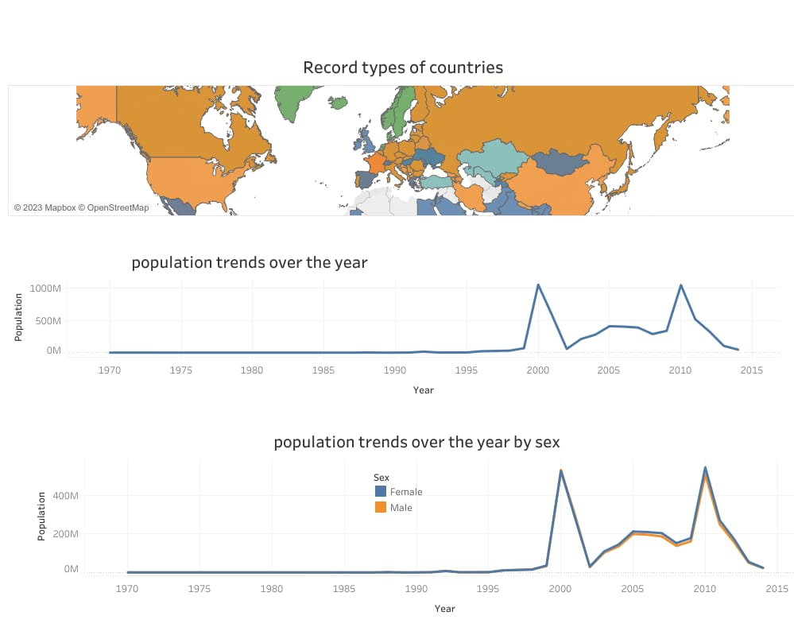

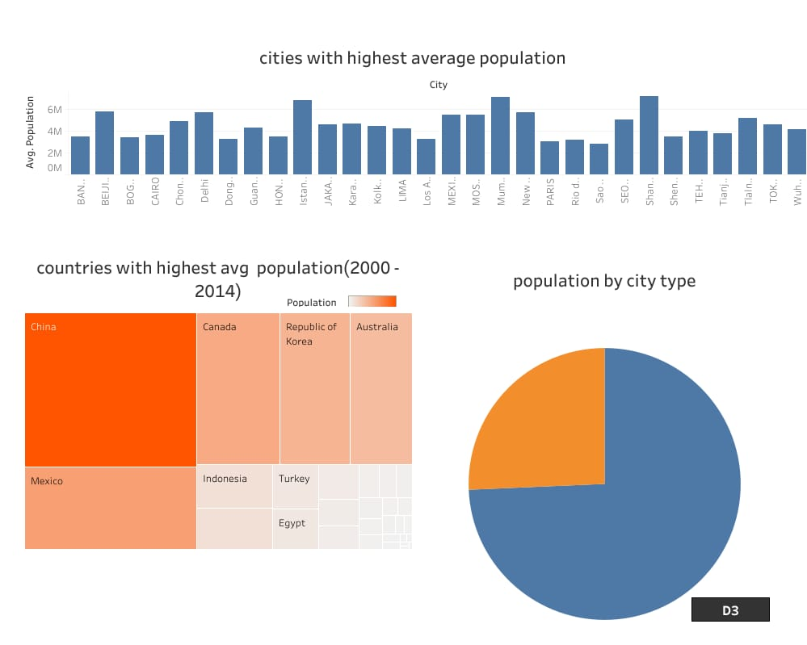

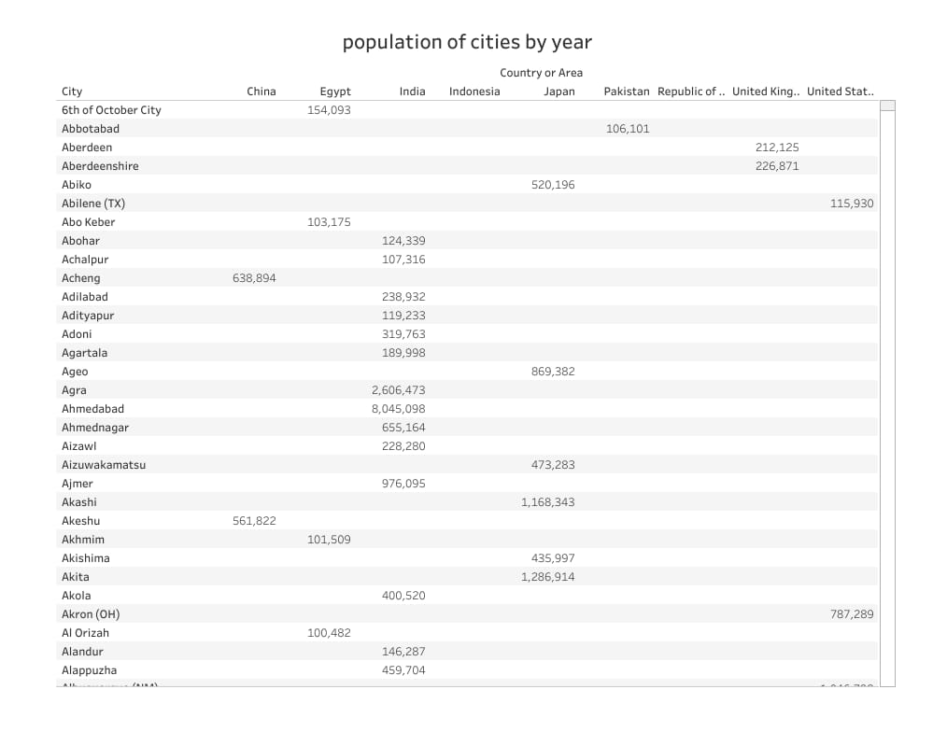

<div class=’tableauPlaceholder’ id=’viz1682158745470’ style=’position: relative’><noscript><a href=’#’><img alt=’ ‘ src=’https:&#47;&#47;public.tableau.com&#47;static&#47;images&#47;ne&#47;new_dashboard02&#47;Dashboard3&#47;1_rss.png’ style=’border: none’ /></a></noscript><object class=’tableauViz’ style=’display:none;’><param name=’host_url’ value=’https%3A%2F%2Fpublic.tableau.com%2F’ /> <param name=’embed_code_version’ value=’3’ /> <param name=’site_root’ value=’’ /><param name=’name’ value=’new_dashboard02&#47;Dashboard3’ /><param name=’tabs’ value=’yes’ /><param name=’toolbar’ value=’yes’ /><param name=’static_image’ value=’https:&#47;&#47;public.tableau.com&#47;static&#47;images&#47;ne&#47;new_dashboard02&#47;Dashboard3&#47;1.png’ /> <param name=’animate_transition’ value=’yes’ /><param name=’display_static_image’ value=’yes’ /><param name=’display_spinner’ value=’yes’ /><param name=’display_overlay’ value=’yes’ /><param name=’display_count’ value=’yes’ /><param name=’language’ value=’en-US’ /><param name=’filter’ value=’publish=yes’ /></object></div> <script type=’text/javascript’> var divElement = document.getElementById(‘viz1682158745470’); var vizElement = divElement.getElementsByTagName(‘object’)[0]; if ( divElement.offsetWidth > 800 ) { vizElement.style.minWidth=’1016px’;vizElement.style.maxWidth=’100%’;vizElement.style.minHeight=’1014px';vizElement.style.maxHeight=(divElement.offsetWidth*0.75)+'px';} else If ( divElement.offsetWidth > 500 ) { vizElement.style.minWidth=’1016px’;vizElement.style.maxWidth=’100%’;vizElement.style.minHeight=’1014px';vizElement.style.maxHeight=”divElement.offsetWidth*0.75)+’px’;} else { vizElement.style.minWidth=’1016px’;vizElement.style.maxWidth=’100%’;vizElement.style.minHeight=’1014px';vizElement.style.maxHeight=”divElement.offsetWidth*1.77)+’px’;} var scriptElement = document.createElement(‘script’); scriptElement.src = ‘https://public.tableau.com/javascripts/api/viz_v1.js’; vizElement.parentNode.insertBefore(scriptElement, vizElement); </script>

<div class=’tableauPlaceholder’ id=’viz1682157615092’ style=’position: relative’><noscript><a href=’#’><img alt=’ ‘ src=’https:&#47;&#47;public.tableau.com&#47;static&#47;images&#47;ne&#47;new_story_16821575342500&#47;Story1&#47;1_rss.png’ style=’border: none’ /></a></noscript><object class=’tableauViz’ style=’display:none;’><param name=’host_url’ value=’https%3A%2F%2Fpublic.tableau.com%2F’ /> <param name=’embed_code_version’ value=’3’ /> <param name=’site_root’ value=’’ /><param name=’name’ value=’new_story_16821575342500&#47;Story1’ /><param name=’tabs’ value=’yes’ /><param name=’toolbar’ value=’yes’ /><param name=’static_image’ value=’https:&#47;&#47;public.tableau.com&#47;static&#47;images&#47;ne&#47;new_story_16821575342500&#47;Story1&#47;1.png' /> <param name='animate_transition’ value=’yes’ /><param name=’display_static_image’ value=’yes’ /><param name=’display_spinner’ value=’yes’ /><param name=’display_overlay’ value=’yes’ /><param name=’display_count’ value=’yes’ /><param name=’language’ value=’en-US’ /><param name=’filter’ value=’publish=yes’ /></object></div> <script type=’text/javascript’> var divElement = document.getElementById(‘viz1682157615092’); var vizElement = divElement.getElementsByTagName(‘object’)[0]; vizElement.style.width=’1016px’;vizElement.style.height=’1014px’; var scriptElement = document.createElement(‘script’); scriptElement.src = ‘https://public.tableau.com/javascripts/api/viz_v1.js’; vizElement.parentNode.insertBefore(scriptElement, vizElement); </script>